**Earthquakes: Questions and activities**

1. In your own words, explain what earthquakes are and what causes them.

________________________________________________________________________________________________________________________________________________________________________

1. Where do earthquakes occur most often?

____________________________________________________________________________________

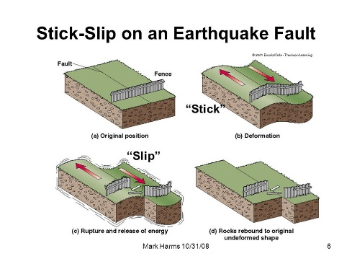

1. Explain the **stick-slip** motion of tectonic plates that causes earthquakes.

_______________________________________________ _______________________________________________ _______________________________________________ _______________________________________________ _______________________________________________ _______________________________________________

1. 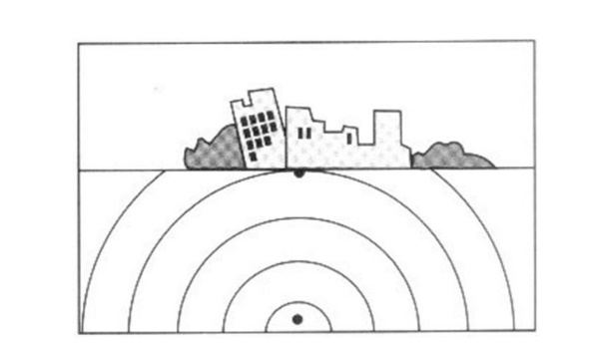Use the diagram to explain the difference between the focus and the epicentre of an earthquake.

__________________________________________________________ __________________________________________________________ __________________________________________________________

1. What sort of damage can earthquakes cause?

________________________________________________________________________________________________________________________________________________________________________

1. Scientists use the Richter scale to measure the size of earthquakes.
   1. What does a 1 step increase on the scale mean in terms of an earthquake’s size?

________________________________________________________________________________________________________________________________________________________________

* 1. What is the name of the instrument used to measure earthquakes? Briefly describe how it works.

________________________________________________________________________________________________________________________________________________________________

1. Describe the earthquake activity for the locations marked on the world map. Write your answers in the spaces below.

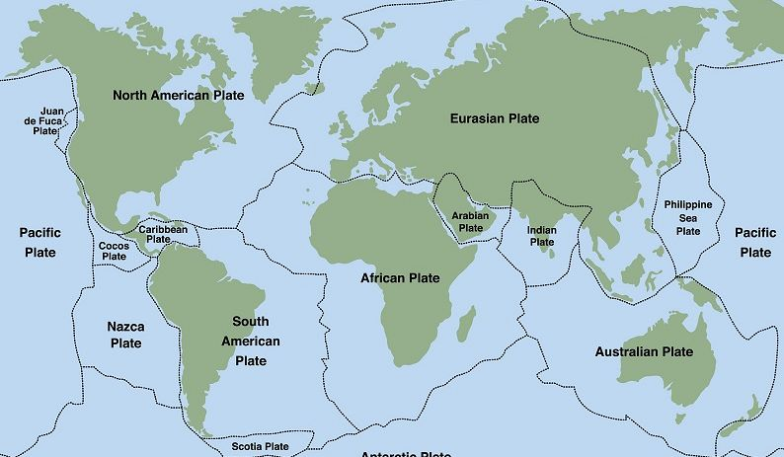

Wellington

Los Angeles

Tokyo

Copenhagen

Salvador

* 1. Tokyo  
     ________________________________________________________________________________________________________________________________________________________________
  2. Los Angeles  
     ________________________________________________________________________________ ________________________________________________________________________________
  3. Copenhagen

________________________________________________________________________________ ________________________________________________________________________________

* 1. Wellington  
     ________________________________________________________________________________ ________________________________________________________________________________
  2. Salvador  
     ________________________________________________________________________________ ________________________________________________________________________________